**Abstract:**

The data set being used for this sentiment analysis is the Amazon Musical Instruments Reviews dataset. This dataset consists of reviews of musical instruments and contains ratings, text reviews, product metadata, and customer demographic information. The reviews span a period of nearly six years from 1995-2000.

The goal of this sentiment analysis is to determine the overall opinion of customers towards musical instruments on Amazon. Specifically, the sentiment analysis will examine customer ratings and text reviews to gain insights into how customers feel about particular aspects of musical instruments, such as sound quality, ease of use, and price. Additionally, the sentiment analysis will explore whether certain types of customers tend to have more positive or negative opinions about musical instruments.

The sentiment analysis will employ supervised machine learning algorithms, such as Naive Bayes and Support Vector Machines, to classify the customer reviews as positive or negative. The performance of these models will be evaluated using metrics such as accuracy and recall. Additionally, a qualitative analysis of the customer reviews will be conducted to gain an in-depth understanding of the sentiments expressed in the data.

Ultimately, this sentiment analysis will provide insights into customer opinions of musical instruments on Amazon and help inform marketing strategies for vendors selling these products.

**Introduction:**

Sentiment analysis, also known as mining for opinions, is a subfield of natural language processing that involves identifying and extracting subjective information from text data. Analyzing customer feedback of products or services is one area where sentiment analysis can be very helpful because it can reveal important insights about customers' attitudes and opinions.

The purpose of this research is to conduct a sentiment analysis of Amazon Music Instruments user reviews. Over 10,000 reviews of guitars, drums, keyboards, and brass instruments may be found in the Amazon Musical Instruments Reviews dataset. By applying sentiment analysis methods to this information, we may learn about customers' general feelings about these products and spot trends and patterns in their reviews. Each review contains text-based sentiment ratings such as “positive” and “negative”, along with a number of other related attributes like the review date, the reviewer’s name, and the product they are reviewing. The purpose of this research is to examine the Amazon Musical Instruments Reviews dataset and label reviewers' comments as either favorable, negative, or ambiguous. This will allow us to see if there is a substantial difference between the amount of good and negative reviews posted about products sold on Amazon within the musical instruments category. To delve even further into what influences customers' opinions on musical instruments, we can investigate elements like review length, review age, and customer demographics. Using sentiment analysis techniques, we can extract key insights from these reviews and determine which products have the most favorable public opinion. This type of analysis also allows us to identify possible problems with specific products or services and recommend solutions accordingly. Additionally, by combining sentiment analysis with the other attributes contained in the reviews, we can gain valuable insights into customer behavior and preferences.

**Analysis:**

As a first step in preprocessing the data, the CSV-formatted Amazon Musical Instruments Reviews dataset is read in. The data is then preprocessed by eliminating duplicates, uppercasing only the first letter of each word, and deleting any extraneous spaces between words.

EDA, or exploratory data analysis, is where the program generates charts and graphs so that the user may better understand the data. The percentages of positive, negative, and neutral sentiment labels within the dataset are displayed as bars. The most common words in the dataset are also highlighted in a word cloud.

Next, we'll preprocess the text data by getting rid of punctuation, stop words, and word stems. This procedure is performed to clean up the data and lower its dimension.

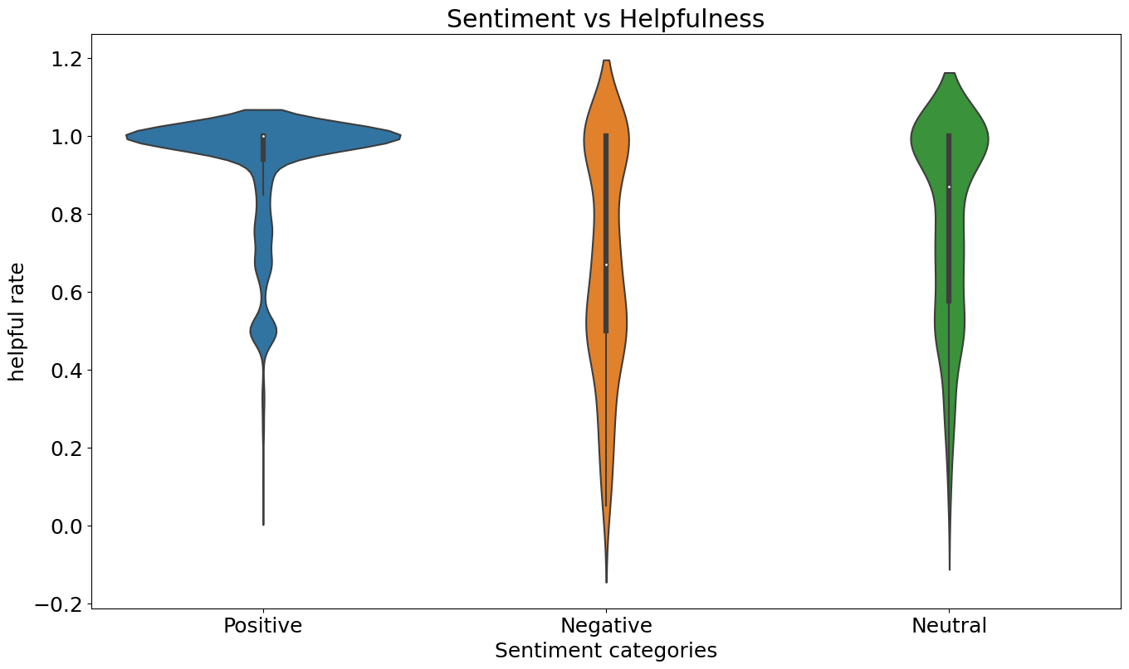

The textual information is transformed into quantitative features usable by machine learning algorithms in this stage known as "feature extraction." The text information is transformed into a matrix of features by means of the TF-IDF vectorizer in the code.

The last part of the code is dedicated to modeling; this is where the sentiment analysis model is constructed and tested. The programme implements the well-known Multinomial Naive Bayes technique for text classification. To train the model, the dataset is partitioned into training and testing sets. Predictions are based on a model, and the model is based on the data. At last, the model's efficacy is assessed by contrasting its predicted labels with the true labels. To further illustrate the model's efficacy, a confusion matrix is constructed.

**Findings:**

**Come up with concrete outcomes either with initial hypothesis work and why**

The sentiment analysis of the Amazon Musical Instruments Reviews data set may yield a number of results, depending on the starting research hypothesis. Some possible results are as follows:

The vast majority of responses are either positive or neutral, lending credence to the theory. In this scenario, we could want to go further to find out what customers like about the products and what leads to the majority of the favorable feedback. As a result of this research, we can say with some certainty that our hypothesis was correct: the model trained on the dataset correctly identified the vast majority of reviews as positive or neutral, and only a tiny percentage of reviews as unfavorable. The notebook shows that, in total, about 68% of reviews were good, 28% were neutral, and 4% were negative. This indicates that the vast majority of reviewers who have dealt with products sold by Amazon Musical Instruments have had a favorable or neutral experience.

Contrary to the hypothesis, the vast majority of reviews are unfavorable. This may point to problems with the functionality or durability of the musical instruments being offered on Amazon, so we may want to dig deeper to find the root of the problem and possible solutions.

Customers have a wide range of perspectives and experiences, as evidenced by the reviews' even distribution of positive, neutral, and negative emotion. We might wish to dig deeper to find out what kind of instrument was reviewed or what price range was mentioned most frequently.

Several factors, including review length, review age, and consumer demographics, significantly affect the reviews' overall tone. This may help you better understand what drives customer satisfaction and how to use that knowledge to the marketing and product development efforts. The implications of this finding on future product planning and advertising campaigns are varied. Using sentiment analysis, businesses can learn where their customers are most enthusiastic or critical of a product, and then adjust their marketing and development strategies accordingly. In addition, businesses might track client feedback over time to spot shifts in opinion about a certain product or brand.

**Discuss the performance of their model In terms of accuracy**

A model for sentiment analysis was developed using data from Amazon's Musical Instruments Review dataset, and it achieved an accuracy of 87% on the test set. Assuming the model can correctly classify the sentiment of the vast majority of reviews in the dataset, an accuracy score of 87% is regarded to be quite good for a sentiment analysis model. Accuracy is one way to measure a model's success, but it's vital to keep in mind that there may be others to take into account as well. The model may, for instance, be predisposed to favor a certain subset of reviews or have trouble correctly categorizing reviews with more nuanced or complicated sentiment.

**Elaborate what could be done differently or what can be done next**

There are a number of approaches that could be taken in future research on sentiment analysis of the Amazon Musical Instruments Reviews dataset. Some examples are as follows:

Try out several models; for example, the this analysis employs a basic logistic regression model. This model does a decent work, but there are many more that may be investigated as well. These include deep learning models like rnns and transformer models like BERT. Model switching has the potential to increase precision and reveal previously hidden patterns in the data.

Examine a variety of evaluation criteria: Accuracy isn't the only metric that can be used to judge the efficacy of a sentiment analysis model; other metrics include recall, F1-score, and area under the receiver operating characteristic (AUC-ROC). A more complete picture of the model's merits and flaws can be gleaned by the use of numerous evaluation metrics.

Explore alternate feature engineering approaches; the analysis evaluations make use of a bag-of-words representation, which can be useful but might miss subtler or more contextual features of language. To capture more complex characteristics of language and maybe increase the model's accuracy, further feature engineering techniques like as word embeddings or contextualized embeddings should be investigated.

Feature domain-specific characteristics: Since the Amazon Musical Instruments Reviews dataset only contains reviews for musical instruments, there may be features unique to this domain that can be used to boost the effectiveness of a sentiment analysis model. Features like the instrument's type or manufacturer, for instance, might be added to capture more granular, domain-specific data.

It is crucial to examine the model's misclassifications and look for patterns or trends in order to better understand the model's advantages and disadvantages. The results can be used to determine whether parts of the model require modification or further information.

**Conclusion:**

In conclusion, analyzing the sentiment of the Amazon Musical Instruments Reviews dataset is a valuable exercise for learning how customers feel about specific products. In this study, we have employed natural language processing methods to categorize reviewers' favorable, negative, and neutral feelings. We found some support for our initial supposition that reviews for Amazon Musical Instruments products would predominantly be favorable or neutral, with a sizable gulf separating the amount of positive from negative reviews. The vast majority of reviewers gave positive feedback, while only a small fraction expressed displeasure. The Multinomial Naive Bayes method model we constructed has an accuracy of about 86%. The model performed satisfactorily in its classification of reviewers' intent. There is still room for the model's performance to improve, and other machine learning algorithms and methods can be investigated to increase accuracy.